It is a very important feature of prop because with the help of props you can pass data between component and send the data

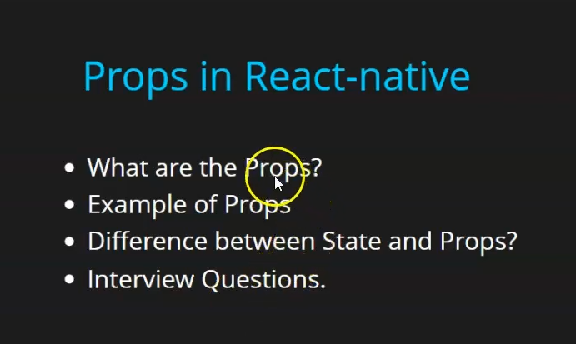
So first teacher will tell us in details what are the props
Even the basisc idea is given by teacher the teacher will tell it in detail
Then we will see the exaample of prop
How to use it and implement
later he will tell us difference between props and States
It is imporant becasue in interview often this question is asked
0:30
Such type of question are often asked
In lst we will discuss more interview question related to props and components
So first question is what is props
these are argument or parameter of the components
Like in fubnction if you want to pass some data or variable then How you do it for that we pass some parameter or argument
In the similar way if we want to pass the data between component then we pass props , argument
Alright how to do it or implement it
suppose we create another component in the same file because it will be in front of you then you can understand easily

function App() {
const [name,setName] = useState('Jatin')
let data = 10
const testName=()=>{
setName('Ramu')
}
return (
<View>
<Text style={{fontSize: 30}}>{name}</Text>
<User/>
</View>
);
}
const User=()=>{

return(
<View>
<Text style={{fontSize: 30}}>Child Component</Text>

</View>)
}

Now our code will look like above
Now we style our view in User component

const User=()=>{

return(
<View style={{backgroundColor:'red', padding:5}}>
<Text style={{fontSize: 30}}>Child Component</Text>

</View>)
}

We will learn about style later

Now our output will look like below

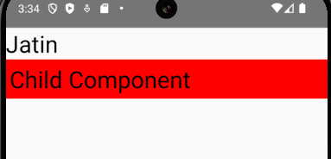
the red colored area repesent our chils component

Suppose we have a variable inside App Compoentn we are using normal variable for now but we are using normal variable later we will use state
We name the variable age and give it value 23
Now to pass the variable age to the User component we use props
So we can pass the props to the User component by adding any named property to the User Component used in App component for now we use the parameter age as shown below

<User age={age}/>

and wwe pass it age variable as shown above
and inside User component we pass the perimeter of any name that is props and
if we try to print it on console by using console.warn

const User=(props)=>{
console.warn(props)
return(
<View style={{backgroundColor:'red', padding:5}}>
<Text style={{fontSize: 30}}>Child Component</Text>

</View>)
}

Now when you load your app and then see the debugger

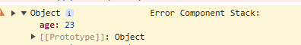
you will see the object that is hgaving property age and that have value 23 the is teh value we have passed inside the User inside App
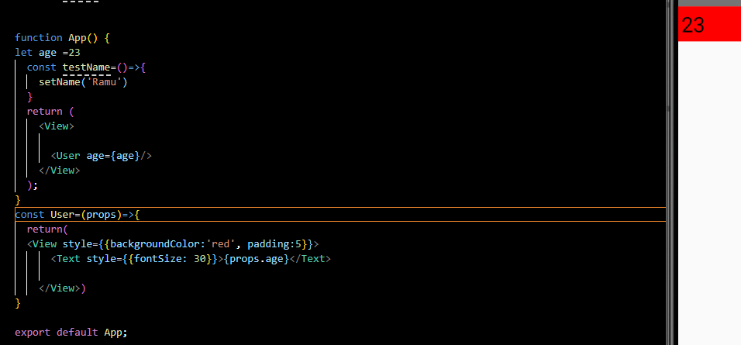
Now you can see in our output showing 23 we pass to the User component by age variable using props
Now we change the value of age to 22 then it will shown 22 as shown below


4:55
Now supppose we want to updte it then how we will do it We will see it
Now we willl add a button named as Update props
Now we will add a click handler to change the age but as the teacher has told previously that we cannot change variable directly
For that we need state so we replace let age with state as shown below

const [age,changeAge] = useState(22)

Now if you update by the onPress of a button then age change will be reflaected inside the nested component to which the props are passed

We can add event handler to a button like below

<Button title='Update props' onPress={()=>{changeAge(50)}}></Button>

Now instead of creating different function and then assigning it to onPress we can do it like above by passing arrow function to the onPress function
So out put is like below

Before

After clickong on teh button output will be like below

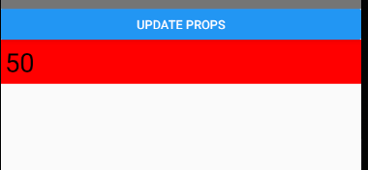
It is often asked can we pass more then one props
Yes we can sa shwon in the code below

const [age,changeAge] = useState(22)

return (
<View>
<Button title='Update props' onPress={()=>{changeAge(50)}}></Button>
<User age={age} name="JAtin"/>
</View>
);
}
const User=(props)=>{
return(
<View style={{backgroundColor:'red', padding:5}}>
<Text style={{fontSize: 30}}>{props.age}</Text>
<Text style={{fontSize: 30}}>{props.name}</Text>

</View>)
}

Note:-

If we does not see the changes in the emulator then reload it by ctrl+M and then to Reload

Now one question which is oftern asked in interviews
When we pass props we pass it from parents to child can we pass it vice versa means from child to parent
Yes we can but it is very much complicated
Teacher for now will not tell us about it now
He will tell us in later lesson
There is a specific term used that is lifiting up state
If you hae gopod knowledge in React js then you might know it otherwise teacher will tell us himself later in upcoming lesson

Now next question is that can we send data directly to another component
No Even if we are sending it then we are doing so by the props which is indirect way
It will not be like you make one state in App component and then try to access it in user component
ithout passing it through props It will not be possible
State is always used inside component
So if you went to send data from one component to another component you can do so through props

Similarity between a state and prop is that is that when a state is updated then our component get rerender but when a prop is updated then our component will get rerender but when a varibale value is cahnges thencomponent does not get rerender
So we have seen many interview question here

